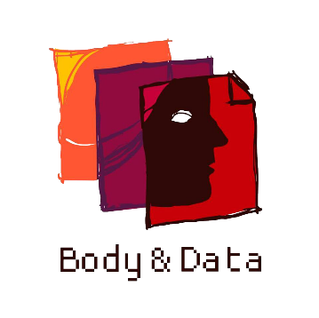
Body & Data
Annual Report
2019

TABLE OF CONTENTS

INTRODUCTION 1
KNOWLEDGE GENERATION 2
ENGAGEMENT THROUGH ONLINE CAMPAIGNS 3
#MyPromise 3
Online Gender Based Violence 4
16 Days of Amplify Activism 5
Twitter Chat on Online Violence and Experiences in Online Spaces 5
ADVOCACY FOR FEMINIST INTERNET 6
Intervention in National Policy 6
Intervention in Internet Governance Forum 7
CONSTITUENCY BUILDING 8
Expanding our Network 8
Cross Movement Collaboration 9
FORUMS AND AFFILIATIONS 12
OUR TEAM 14
PARTNERS AND SUPPORTERS 18

INTRODUCTION
Established in 2017, at Body & Data, we believe in creating a free, open and just internet where women and queer people can exercise their agency and autonomy with suitable technologies and secure digital strategies. Our aim is to work in a right-based approach where women and queer people, where they can access internet and other forms of technology, with available digital security measures.
For the year of 2019, we focused on occupying national, regional and global spaces, through independent or affiliated events, working for internet freedom and digital rights through the perspectives of gender and sexuality. Through working with women's rights and queer rights activists, sexual health advocacies, journalists, young women, students, techies, human rights activists and other allies, we aim to provide a safe and feminist space to learn, share and discuss the intersectionality of gender, sexuality and the internet, in online and/or offline spaces.
We would like to thank all the well-wishers, individuals and organizations that collectively came together for a feminist internet we hope to achieve, and for active participation and support for the campaigns, workshops, participation and advocacy we led in the year of 2019.

KNOWLEDGE GENERATION
Collection and generation of resources is a part of our working area where we want the marginalized community to be heard, and their voices expanded through our advocacies and campaigns.
In 2019, we conducted a scoping study on the “Internet Use, Challenges and Opportunities” where the focus group of the research was young people in urban areas, with specific focus to queer people of Nepal and their use of internet.
As a partner in ‘Expanding EROTICS Network in South Asia’ project we are doing Regional Monitoring Survey in Nepal. The quantitative survey has been completed with 201 respondents. The survey was done through open call for participation as well as in person visit with around 105 targeted people from young people, queer groups, women rights activists, women with disabilities, entertainment sector women workers, etc.
Qualitative research on EROTICS has been going with focus on the intersection of internet and sexuality of women with disability. For the same, 16 individuals are being interviewed along with focal group discussions surrounding issues of exploration of sexualities, lived experiences of women with disabilities on the online, their difficulties and pleasures on the internet and technology.
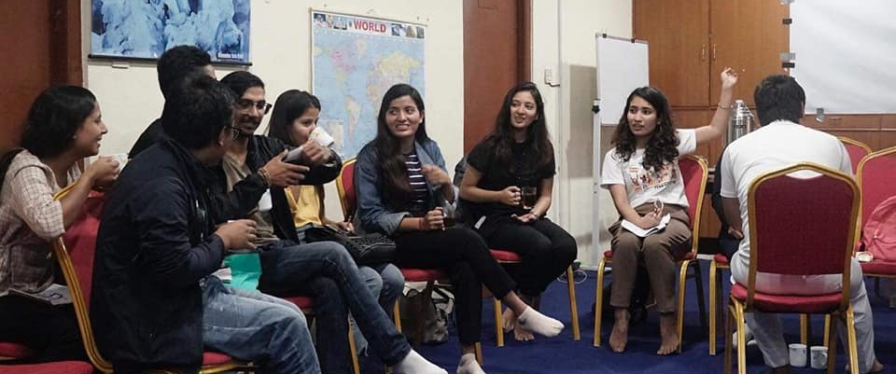
Orientation with Members of Y-PEER (Youth Peer Education Network) Nepal on Gender, Sexuality and Internet

ENGAGEMENT THROUGH ONLINE CAMPAIGNS
We believe it is important to be vocal, visible and run campaigns on the internet to contribute to the advocacy for women and queer people's rights. Discourses surrounding the issues of freedom of expression, privacy, censorship, surveillance and policies that effect marginalized community should be magnified on the internet.
For the year of 2019, we also engaged with our communities through our social media channels. In the changing context of Nepal, social media has been an effective communication tool to launch campaigns and highlight our agendas and issues among diverse group of people. Through our online campaigns, we were able to reach and engage with over 2500 people through our Instagram, Twitter and Facebook.

#MyPromise
We launched #MyPromise campaign on Instagram, through which different nuances of consent and sexual and gender identity were brought forth. The main agenda of the campaign was to pledge promises to practice an d look out for enthusiastic consent.
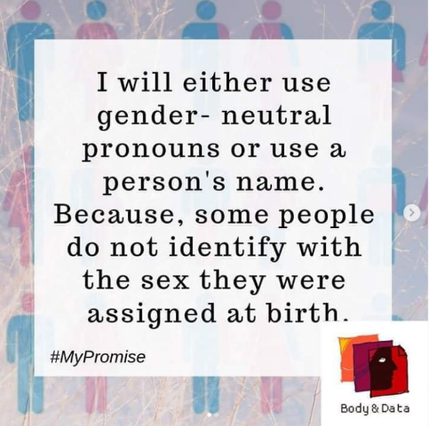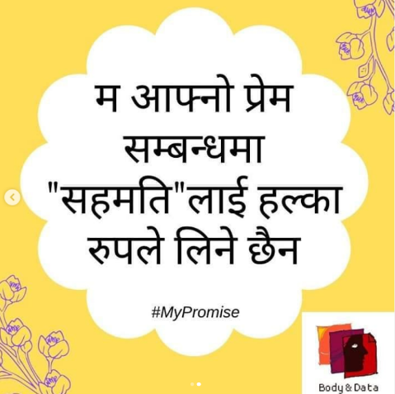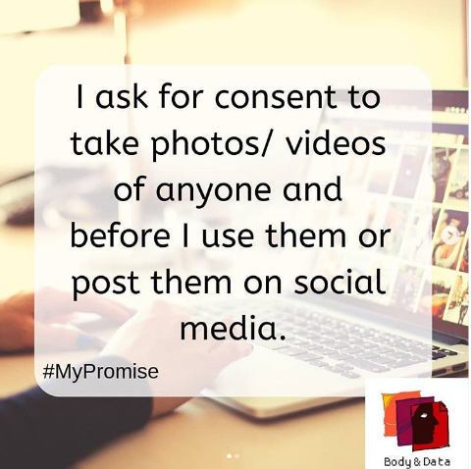
My Promise Campaign Graphics

Online Gender Based Violence
Through the campaign of Online Gender Based Violence, we reached out to over 1000 audiences through Instagram and Facebook. We wanted to expand discourses on what are the different types of gender based violence, in both English and Nepali languages.
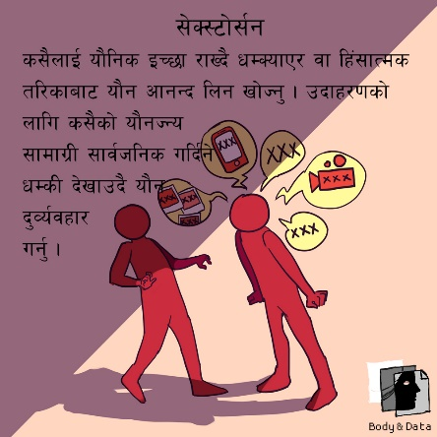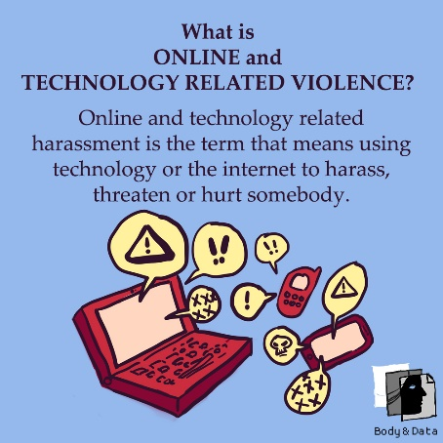

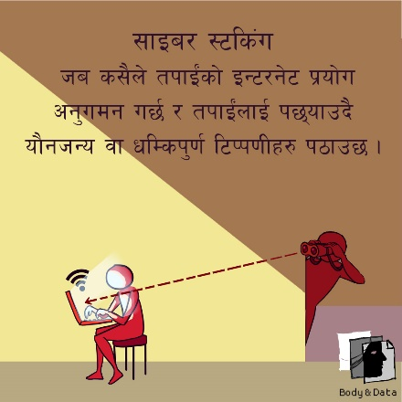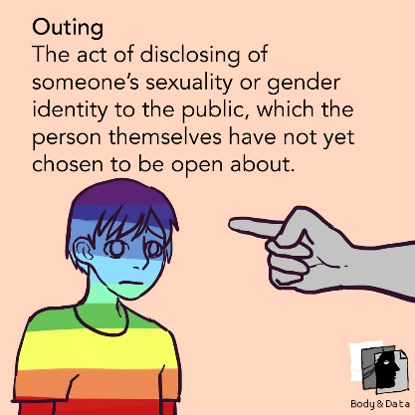
Illustrations for Online Gender Based Violence

16 Days of Amplify Activism
On the occasion of 16 Days activism, we took part in amplifying activism and campaigns of different like-minded national and regional organizations. By partaking in different conferences, events organized by different organization in Nepal, we took part in building solidarity and movement in a more collective manner to amplify the work and issues of gender, sexuality and digital rights
The #AmplifyActivism was an initiative to share different activities and posts on social media happening around 16 days Activism both national and regional level, to show that discourses on said issues are happening around us.

Twitter Chat on Online Violence and Experiences in Online Spaces
We organized a twitter chat to bring out different experiences of people online, as well as the different types of violence they have experienced. The twitter chat brought forth various narratives of lived realities of people in the country. The twitter chat gathered about 100 individuals to engage and participate in the questions, polls and replies in English and Nepali language.

ADVOCACY FOR FEMINIST INTERNET

Intervention in National Policy
We organized a consultation event among civil societies to review selected chapters related to information security, privacy, cyber security and social media in the Information Technology (IT) Bill. We analyzed the bill from gender and sexuality lens, keeping into consideration the aspect of privacy, online gender based violence, data protection, Freedom of Expression (FoE) and Freedom of Assembly and Association (FoAA).
The analysis was focused on the implications of the bill to women, sexual minorities and marginalized communities. We were able to discuss the bill among people from backgrounds of law, gender, sexuality, human rights, media, disability rights and students. On the basis of the discussion, we drafted a policy brief which was further used for our advocacy and campaigns that we launched in our social media channels.
Furthermore, we participated and presented the analysis in IT Bill Discussion program jointly organized with civil societies among parliamentarians, civil societies, private sectors and concerned stakeholders.
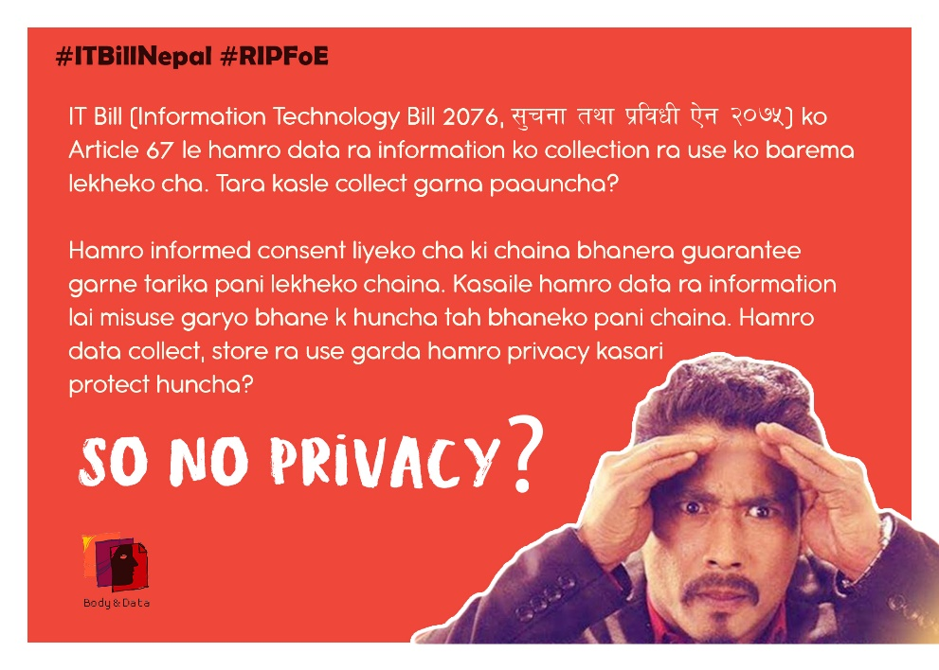

Intervention in Internet Governance Forum
We raised the issue of internet freedom from gender and sexuality lens through Internet Governance Forum (IGF) Nepal, where we held two plenary discussions on "Intersectionality in Internet: Diversity and Representation" and “Merging Online and Offline World - Pleasures of Internet". The aim of these sessions were to highlight different intersections of internet in gender, sexuality, disability, queer rights (LGBTIQ+).
Along with the national IGF, our team members also participated in the Asia Pacific regional IGF in Russia and the Global IGF in Berlin. Prior to the global IGF, we also co-facilitated a discussion on sexuality and internet governance.
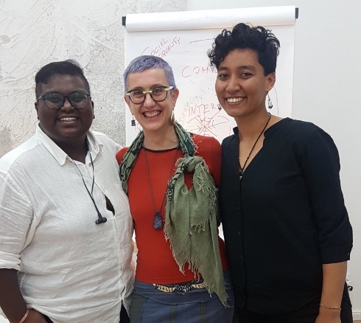
Global Internet Governance
Forum 2019, Berlin
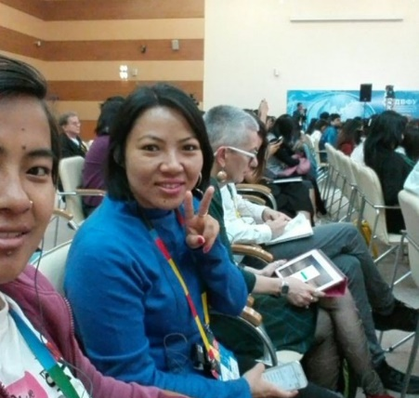
Asia Pacific Regional Internet Governance Forum 2019, Vladivostok
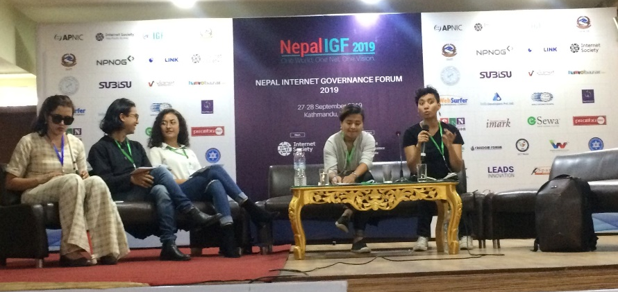
National Internet Governance Forum Nepal 2019, Kathmandu

CONSTITUENCY BUILDING
The issue of internet freedom, let alone through a feminist lens is particularly new in the context of Nepal. Hence, we actively collaborated with different ally organizations working in the fields of gender, feminism, sexuality and digital rights, and tried to interlink the working areas of each other. We worked on building solidarity and collaborative movement building on our quest for a more feminist internet.

Expanding our Network

We organized two workshops on “Feminism, Sexuality and Internet – The Missing Link” in collaboration with Point of View, Mumbai for 31 feminists, activists, students, tech people, artists, and queer folks to better understand the interlinking factors between feminism, sexuality and internet. They were given different hands - on tool regarding digital security.
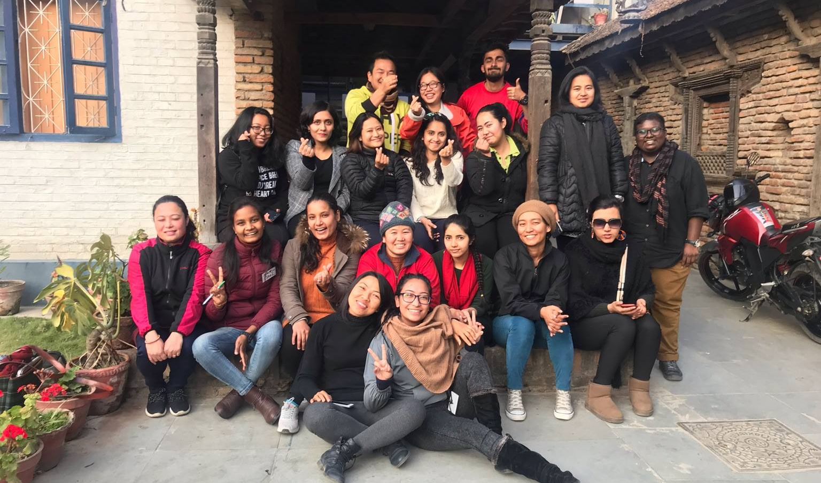
Workshop on Feminism, Sexuality and Internet – The Missing Link

We organized two Feminist Tech Exchanges (FTX) in workshop modality to conduct in depth discourses around data politics, different aspects of digital rights such as freedom of expression, privacy, censorship, alternative economy, feminist internet and hands - on tools of digital safety. We participation from over 40 activists from different background and movements, including women rights activists, sexual rights advocates, feminists, queer individuals, tech enthusiasts and students.
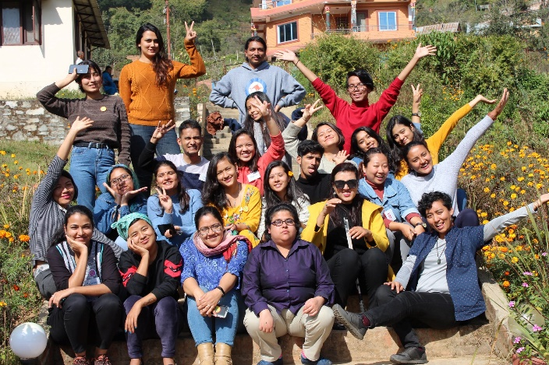
Feminist Tech Exchange I
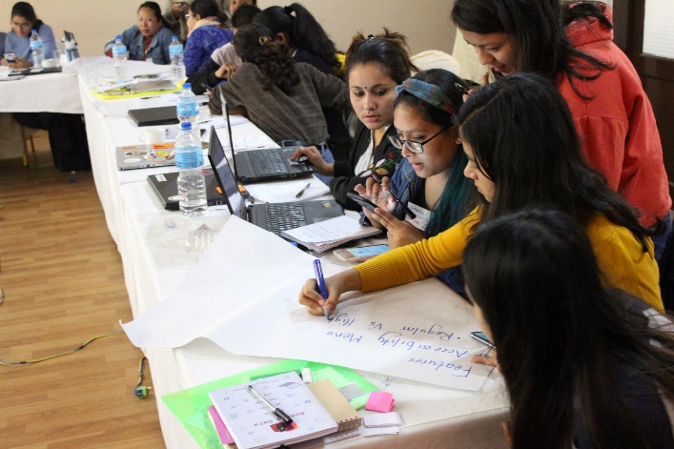
Feminist Tech Exchange II

Cross Movement Collaboration
We collaborated with national organizations such as Tewa, Queer Youth Group, Y-PEER (Youth Peer Education Network) Nepal, Prayatna Nepal, Women Forum for Women in Nepal, Yuwa, Accountability Lab and Social Welfare Association of Nepal to carry out orientations and training sessions. Collectively, over 100 activists from movements such as women rights, disability rights, queer rights were given hands-on tools for privacy, security and digital hygiene while browsing the internet, and discourses how feminist and right based approach in internet would look like.
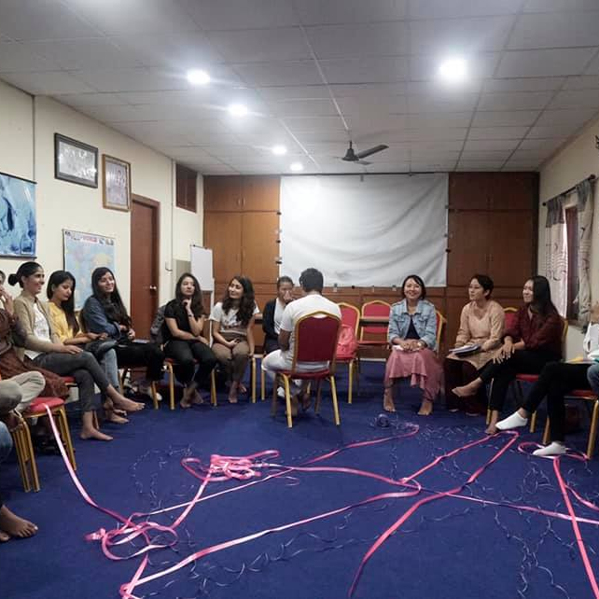
Orientation on Gender, Sexuality and Internet with Youth Volunteers of Y-PEER Nepal
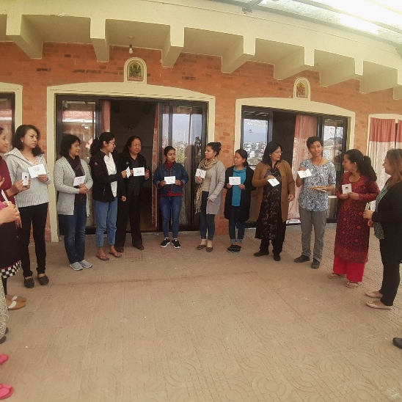
Training on Digital Hygiene at Tewa
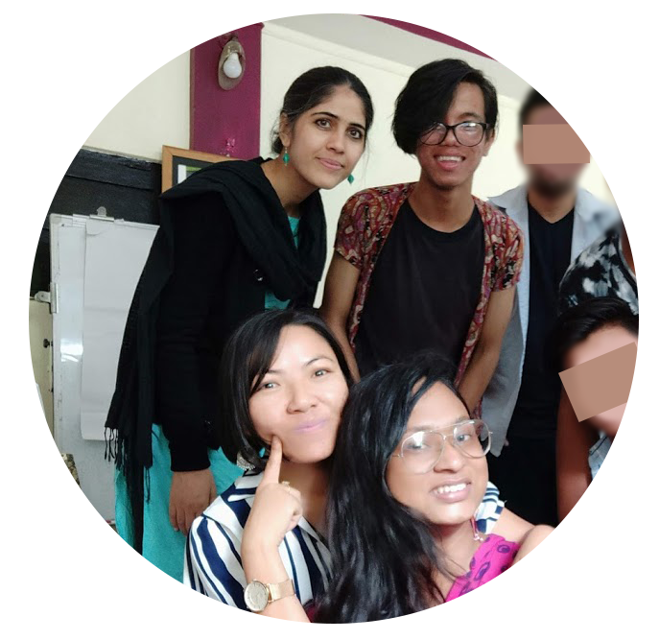
Orientation on Gender, Sexuality and Internet with Members of Queer Youth Group (QYG)
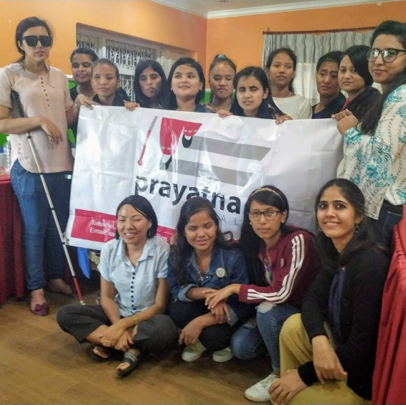
Discussion on Experiences of Women with Disability on the internet at Prayatna Nepal

Similarly, beyond national organizations, we were also invited by Sangat, a South Asian Feminist Network and CREA for Sexual and Gender Institute (SGRI) to conduct sessions on feminist internet as well as the intersectionality of feminism and digital rights. Collectively, we were able to reach over 100 feminist activists from the South Asian region.
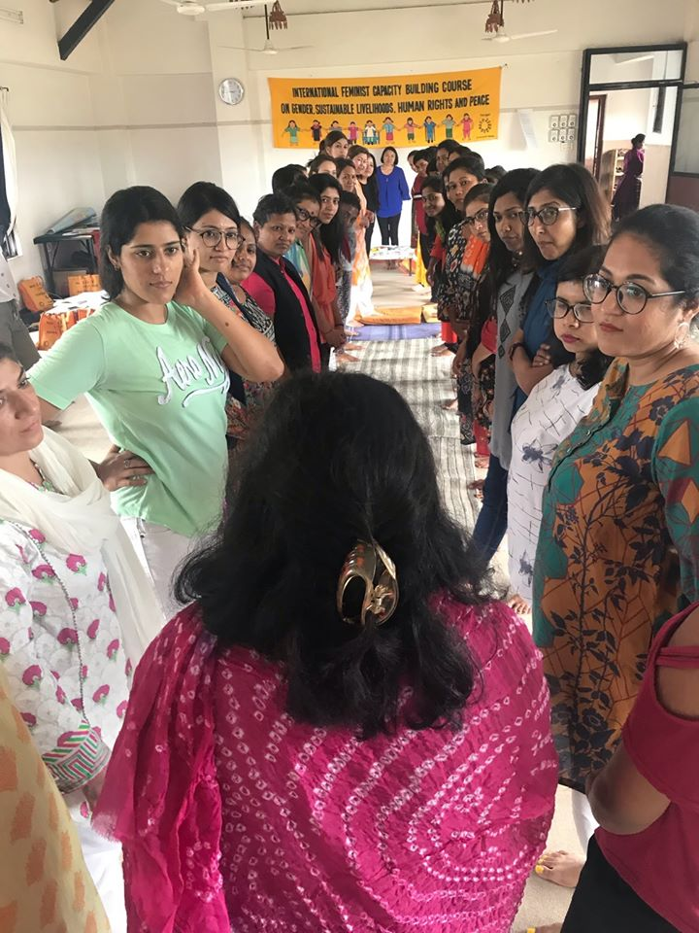
Workshop on Feminist Internet during Sangat - A South Asian Feminist Network
Session on Feminist Internet during CREA's Sexual and Gender Rights Institute (SGRI)

FORUMS AND AFFILIATIONS
For the year of 2019, we focused on occupying national, regional and global spaces, through independent or affiliated events where we were invited to facilitate sessions, speak on panels and participate in discourses on gender, sexuality, digital rights and feminist internet.
We tried occupying feminist spaces, where we incorporated more discussions on digital rights and feminist internet, creating more discourses on agendas that benefits feminist movement. On the other hand, we tried to occupy digital rights spaces to bring human rights perspective in the discussions. We were able to learn and work on the intersection of both movements and broaden our area of work and reach wider mass of youths, women and queer folks.
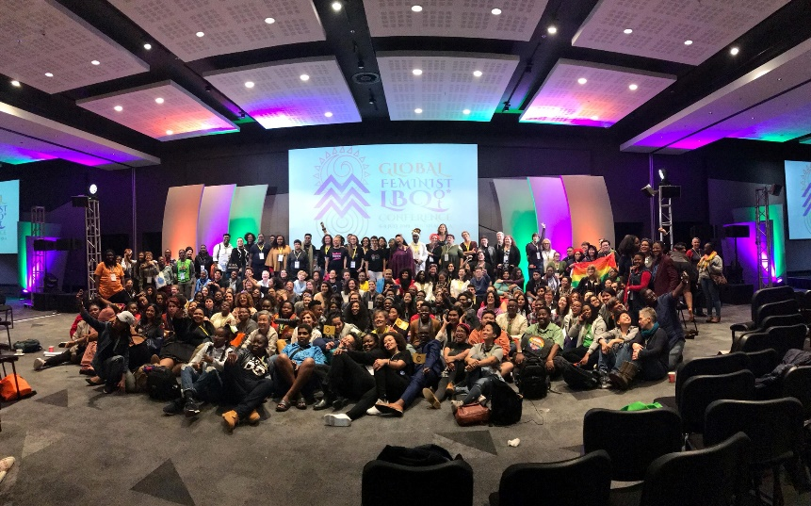
Global Feminist LBQ (Lesbian Bisexual and Queer)
Women's Conference, Cape Town

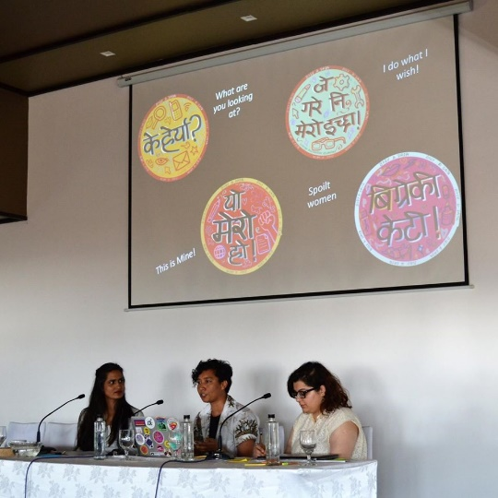
Regional Conference - Imagine a Feminist Internet, Colombo

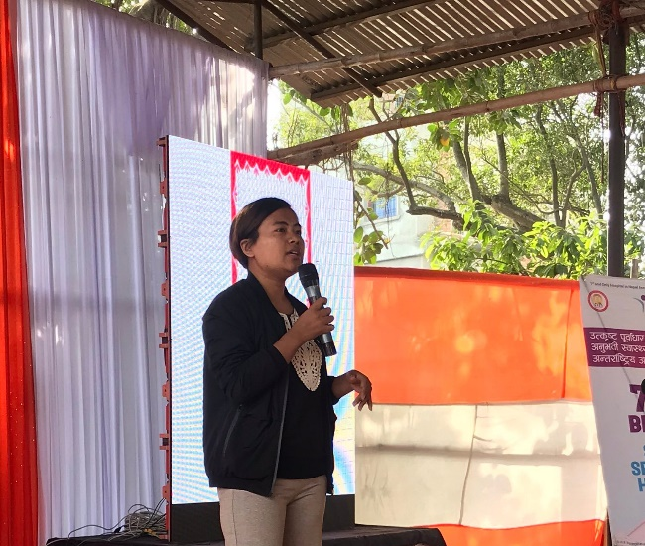
National Event - WOW (Women of the World), Janakpur
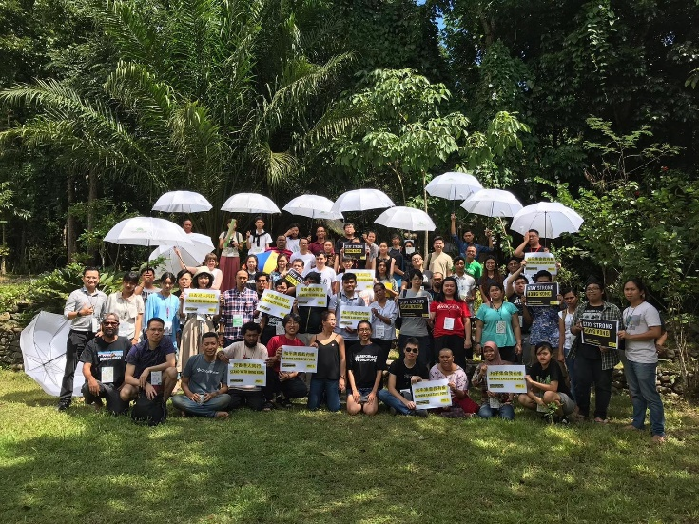
Regional Event - COCONET II, Rizal
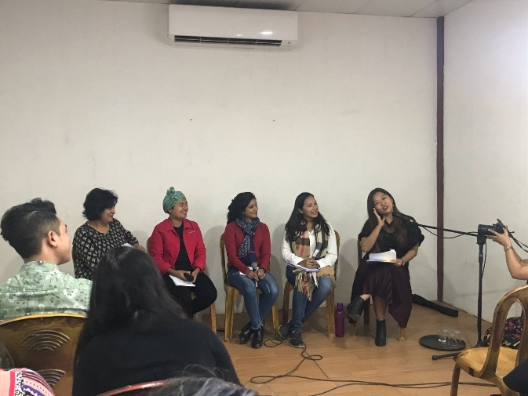
National Event with Boju Bajai - A Feminist Podcast, Kathmandu
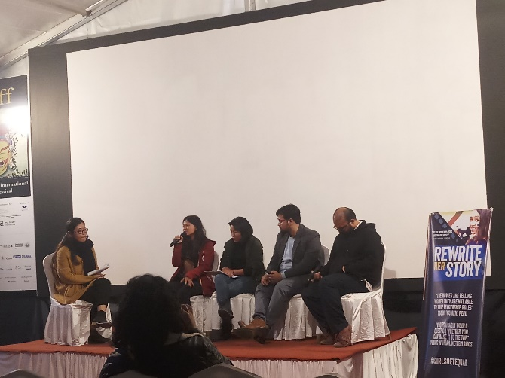
National Event - Rewrite Her Story, Kathmandu

OUR TEAM
2019 has been a transformational year for us, as we welcomed our first board of directors who will be working along with the staffs to further strengthen us and our visions. Our team consists of the following members:

Shubha Kayastha (Co-Founder & Board Member)

Shubha, a queer feminist is the co-founder and executive director at Body & Data. She comes from a background of women’s sexual and reproductive health and rights (SRHR). Bubbly personality with critical mind, you can find this amazing human talking about feminist internet, sexual expression, pleasure and against structural inequality.

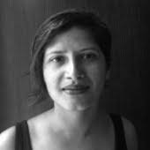Indu Nepal (Co – Founder)
Indu is the co-founder of Body & Data. She is a jack of many trades, but mostly working in the area of information management, sharing, amplifying and other challenging jobs. She is currently working with the International Committee of the Red Cross in their efforts to be more accountable to the people they are working with.

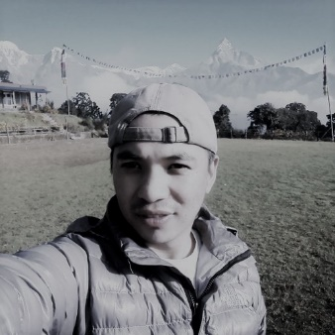Bharat Shrestha (Board Member)
Bharat is a professional development worker on the field of public health, education and social science. He is also queer activist.

Supriya Manandhar (Board Member)

Supriya i s an art director and freelance illustrator. She has also dabbed in journalism, working as desk editor at The Record in 2017-2018. Supriya comes from formal background is in the visual arts and art education. She is a feminist and a Newa Feminist.

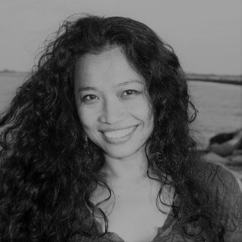Dovan Rai (Board Member)
Dovan did PhD in Computer Science researching on education technology- an interdisciplinary field at the intersection of education psychology, game design, datamining and AI. She did her masters in sociology from TU. She has worked with OLE Nepal for designing educational software for public schools of Nepal. She identifies as a feminist and socialist and she is looking for ways to make feminist socialist impact through technology, particularly AI.

Sarita Lamichhane
Sarita is a visually impaired change maker. She is the founder of Prayatna Nepal which is an organization working to empower visually impaired women to take their life in own hand. Apart from this. She is also a professional motivational speaker.

Rita Shree Baramu (Programme Manager)

Our team consists of this amazing feminist and blogger! Rita comes from the background of gender, law and land rights. You will find her always speaking her mind about women’s, ethnic and minorities’ issues, and leading with a feminist perspective at Body & Data. Being paradox of loud laugh and soft voice, Rita is a force to reckon with.

Kabita Bahing (Program Coordinator)

Our cheery Kabita is a feminist LLB graduate and has mastered in Gender Studies. She has a history of working with child and youth at risk, and is involved in the indigenous movement. Our multi-talented Kabita is also associated with UNYAP, Abiral – The Arts Group and Accountability Lab as Nepal Accountability Incubator.

Youba Rai (Finance Officer)

Youba has been handling the Administration and Finances of Body & Data. Originally from Sankhuwasabha, Youba has been working in the field for past 7 years. She is definitely our residential superwoman.

Shripa Pradhan (Communication Officer)
Currently looking after the communications of Body & Data, Shripa is a feminist who has been an avid debater through Debate Network Nepal. You can always catch her enthusiastically speaking about BTS, her favorite band.
In 2019, we also had Juna Lama in our team, helping us with the daily office working. Sukiti Manandhar, Jevina Pradhan and Kavita Raturi worked as staff members. We had the support of Souprina Bajracharya. Shreya Yonjan, Badal Lama and Dipesh Khanal as interns for the organization. We also had the guidance of Aayusha Prasai, Alina Chantel, Lainie and Nadege who are working as consultants and constant guidance for the organization.

PARTNERS AND SUPPORTERS

We would like to thank our partners and supporters, who believed in our goals and helped shape the organization for 2019. We also appreciate Voices of Women (VoW) Media for supporting us as a fiscal sponsor.
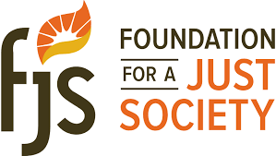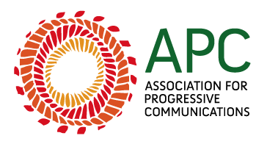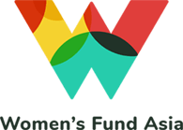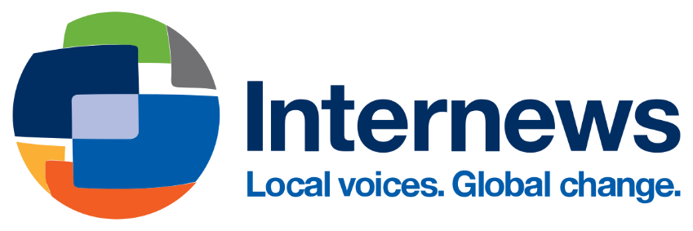
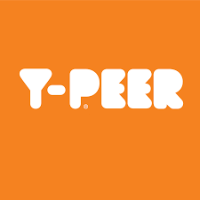
We again, would like to thank all of our team members, ally organizations, partners, and enthusiastic individuals for making 2019 a truly monumental year for a collective movement, as we strive forward for integration of feminism, technology and internet rights. We hope to increase more autonomous participation, agency and visibility of women and queer people online through digitally secure strategies in 2020.
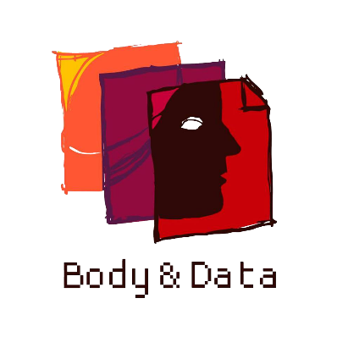

Website:
bodyanddata.org

Twitter/Instagram/Facebook:
@bodyanddata

