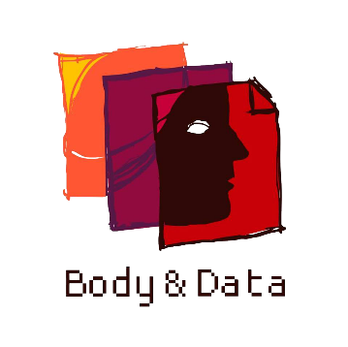

Body & Data
Annual Report 2020

Appreciation post
Through the difficult and confusing year of 2020, we have found a sense of community and belongingness through the people we have worked with, ally organizations we have collaborated with and audiences who have cheered us on.
Through the pandemic and the need for the globe to be virtual and distant, thank you for creating a close knit, believing in our goals and work and co-creating feminist internet and technology. The core team of Shripa Pradhan, Youba Rai, Rita Baramu and Kabita Rai was joined by Dikshya Khadgi and Rukshana Kapali in 2020 and Dipesh Khanal and Safal Lama as interns. Much thanks to Juna Lama for keeping us nourished and happy with good food every day.
We would like to thank Arpana Shrestha, Tara Chamling Rai, Pooja Khati, Supriya Manandhar, Mamata Pokharel, Raji Manjari Pokharel, Dovan Rai, Sarita Lamichhane, Kailash Rai, Kavita Raturi, Sapana Sanjeevani, Aashu Sarraf, Kishor Bayung Rai, Dev Tonimi Bahing, Neha Gauchan, Sikha Neupane, Shailee Chaudhary, Pallavi Payal, Sulav Pradhan, Sarita Baramu, Pratiik Thapa, Deekshya Dahal for working us as consultants, translators, researchers, resource persons in various training programs, research, workshops throughout the year. Thank you helping us co-create safe spaces.
Thank you to Anuska Sthapit worked with us as a consultant for website designing and restructuring. Nadege for website server infrastructures development, Hvale vale supporting us in developing remote working strategies and work-from-home policies, Lainie for the helping us develop communication strategy and Amina Singh for facilitating the strategic plan developing process of the organization.

Shubha Kayastha
Co-founder/ Executive Director

TABLE OF CONTENTS

INTRODUCTION 1
KNOWLEDGE BUILDING 2
Inclusive Nepali Language Guideline 2
Research on Internet Usage, Access and Experience 2
Unshackling Expression: A study on criminalization of freedom of expression online in Nepal 3
Online GBV: Mapping Out Laws Relevant to Online Gender Based Violence in Nepal 3
Consultations on Privacy 4
ENGAGEMENT THROUGH ONLINE CAMPAIGNS 5
Campaign around Information Technology (IT) Bill 5
Misinformation during Corona Pandemic Campaign 6
Campaign Against Online Violence 6
Privacy Campaign 7
16 days of Activism – Mapping Laws Related to Online Violence in Nepal 8
#SupportForNikisha 8
CONSTITUENCY BUILDING 9
CROSS MOVEMENT COLLABORATIONS 11
Cross Collaborations across National Movements: 11
Cross Collaborations across International Movements: 15
FORUMS AND AFFILIATIONS 19
PUBLICATIONS 23
MEDIA 23
ARTICLES 23
OUR TEAM 25
Board Members 25
Staff Members 27
PARTNERS AND SUPPORTERS 29

INTRODUCTION

Established in 2017, Body & Data works to enhance understanding and access to information on digital rights among women, queer people and minority groups where they are able to exercise their rights in a safe and just digital space. We work towards the vision of accessible, safe and just digital space for all, through cross movement building, facilitation for access to information, knowledge building and dissemination on digital rights in the context of Nepal.
For the year of 2020, we practiced the feminist values of care while working with women's rights and queer rights activists, sexual health advocacies, journalists, young women, students, techies, human rights activists and other allies. During the global pandemic, we focused our work addressing the emerging issues arising due to the pandemic, while co-creating safe and learning space to discuss the intersectionality of gender, sexuality and the internet,
We would like to thank all the well-wishers, individuals and organizations that collectively came together for a feminist internet we hope to achieve, and for active participation and support for the campaigns, workshops, participation and advocacy we led in the year of 2020.

KNOWLEDGE BUILDING
Collection and generation of resources is a part of our working area where we want the marginalized community to be heard, and their voices expanded through creating resources, that is further given visibility through campaigns and advocacy programs. Body & Data has intentionally tried to navigate through to develop or compile resources that are scattered when it comes to Digital Rights and its components. Knowledge Generation includes researches, policy analysis, reports.

Inclusive Nepali Language Guideline
On May, Body & Data developed and shared an “Inclusive Nepali Language Guideline” as a part of its knowledge generation program. The guideline is a working document that aims to propose inclusive and gender friendly language for official and communication purposes to civil societies, activists and individuals. It is developed as a tool to deconstruct the heteronormative pattern of the Nepali language and offers the alternatives of such vocabularies. It was initially drafted by Rukhana Kapali and published with inputs by other team members too. A copy of this guideline could be accessed through our website too. Since the publishing of the guideline, the document has been a resource for communities we work with, and has been a part of collection in the Queer Rights Resource – Nepal.

Research on Internet Usage, Access and Experience
To look into the experiences of Nepali people from different walks of life in the internet along with the challenges and opportunities, Body & Data conducted a research with the financial and technical support from Association for Progressive Communication (APC) as part of a regional grant from Amplify for Change for the phase II of EROTICS project. The qualitative part of the research focused on experiences of people with disabilities in the internet and their realities in terms of access, self-exploration and expression in the digital spaces

The qualitative research titled “Beyond Access: Women and Queer Persons with Disability Expressing Self and Exploring Sexuality Online” was conducted and has been disseminated through an online discussion event with people with disabilities and activists working in the sector of disability, sexuality and digital rights. There were 22 participants in the focal group discussion and 16 during interview.
Similarly, a quantitative research titled “Identities Experiencing the Internet: Nepal Survey Report” that includes data of approximately 200 Nepali people around their usage, access and experience on the internet has been conducted and is published.

Unshackling Expression: A study on criminalization of freedom of expression online in Nepal
Body & Data in collaboration with the Association for Progressive Communications and the CYRILLA Collaborative conducted a research on Mapping of criminalization of Expression Online (MCEO)
In the research, laws relating to freedom of expression were studied and analyzed from a digital rights approach. Besides law, case studies, current socio-economic trend, artistic impression, sexual expression online were also analyzed in the research. The main aim of this research was to access the present legal instruments that are used or could be used to curtail the freedom of expression in Nepal.

Online GBV: Mapping Out Laws Relevant to Online Gender Based Violence in Nepal
Body & Data released a chart addressing “Mapping Out Laws Relevant to Online Gender Based Violence in Nepal” which was based off of research on laws relevant to online violence in Nepal. This was a policy mapping and reviews of laws within the scope of digital rights in Nepal, with a focus on gender and sexuality. Three human rights lenses: Right to Privacy, Freedom of Expression and Freedom from Violence were used to analyze relevant laws. This document is meant to be condensed guide for victims, legal practitioners and activists.
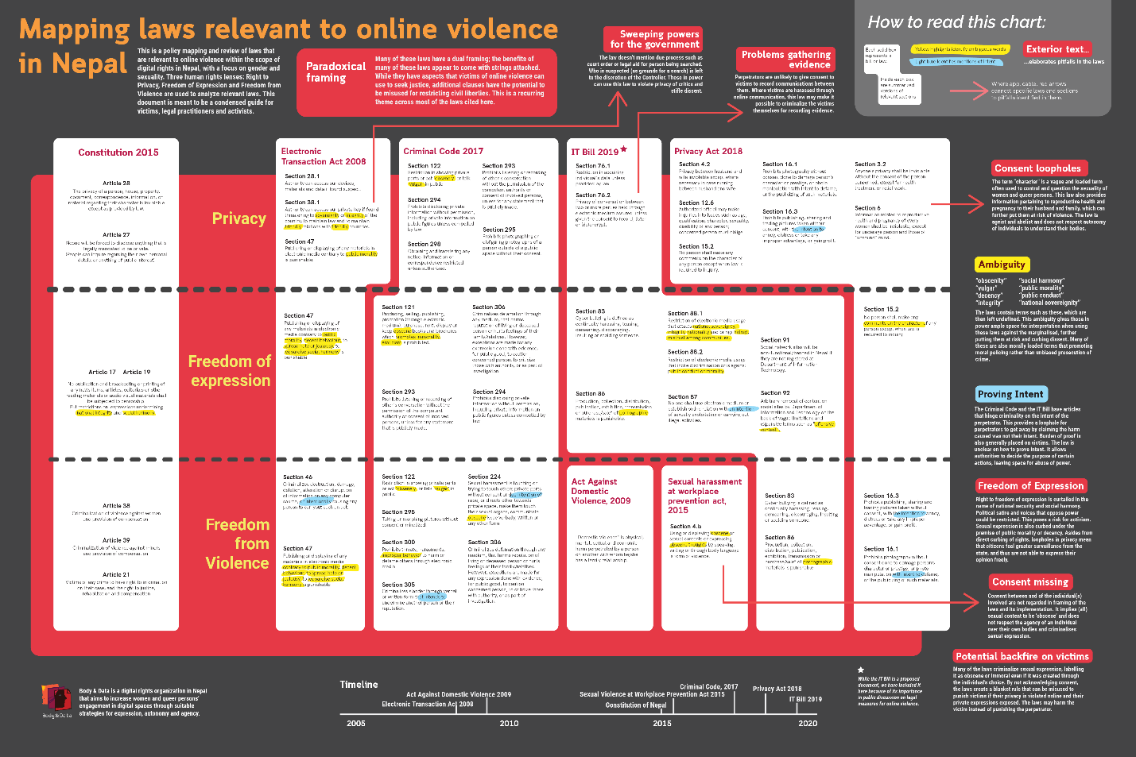

Consultations on Privacy
We organized consultations with various stakeholders around privacy and data privacy. Total five consultations on the issue of privacy was held with different communities such as young women, queer people, trans people, women with disability and Madhesi youths. The aim of these consultation was to initiate dialogues about privacy including data privacy and what it meant to different groups of people while identifying the problems they face concerning privacy in their day to day life.

ENGAGEMENT THROUGH ONLINE CAMPAIGNS
We believe it is important to be vocal, visible and run campaigns on the internet to contribute to the advocacy for women and queer people's rights. Discourses surrounding the issues of freedom of expression, privacy, censorship, surveillance and policies that effect marginalized community should be magnified on the internet.
This year, we have managed to reach a wider audience through our social media platforms (Twitter 1600+, Instagram 1800+ and Facebook 1500+)

Campaign around Information Technology (IT) Bill
Information Technology Bill is one of the most important bill that can dictate our online future. After the analysis and consultation around Information Technology bill on 2019, we released a collection of analysis and critiques of different articles written in the bill. The analysis was focused on the implications of the bill to women, sexual minorities and marginalized communities.
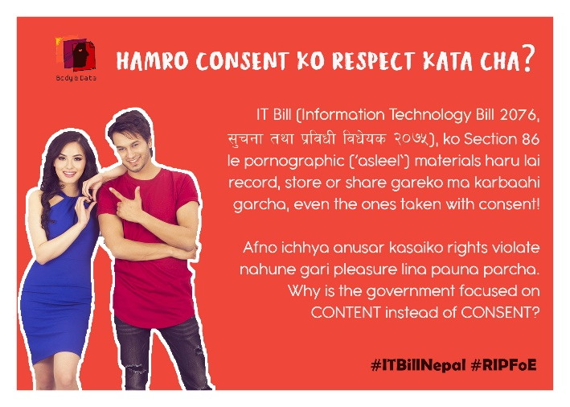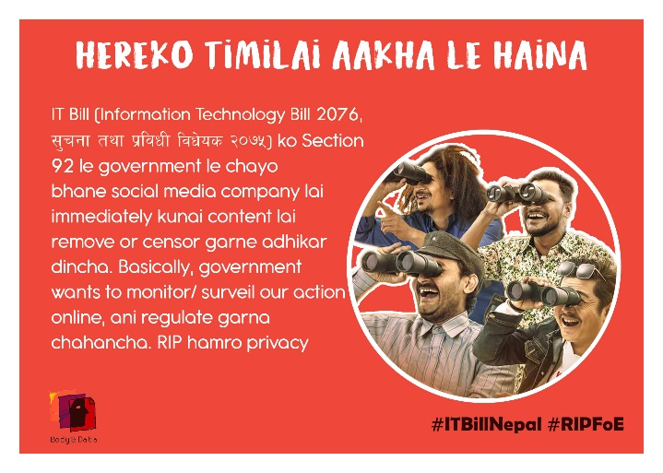

Misinformation during Corona Pandemic Campaign
Following the stay-at-home orders and rise of numbers of covid-19 cases, there was a surge of misinformation online about the pandemic. Addressing the issue, we launched a campaign to "Misinformation During Corona Pandemic" during the months of March till May. The main objective of the campaign is to understand different misinformation about the pandemic that is present online, their harms and how to counter them. Misinformation and Disinformation is a harm to our Right to Information, and through online means the harms is escalated and multiplied.
The first part of the campaign was to know the general idea/ opinion of the public regarding different aspects of misinformation - common misinformation people have about corona around them, reliability of social media, and fact checking methods that people use. The second part was to focus specifically on different types of harms that misinformation has specially to marginalized folks and preexisting stereotypes against them. The third part comprised of sharing and bringing attention to various tools, platforms and websites that people can use for fact checking different news and information found around the pandemic.
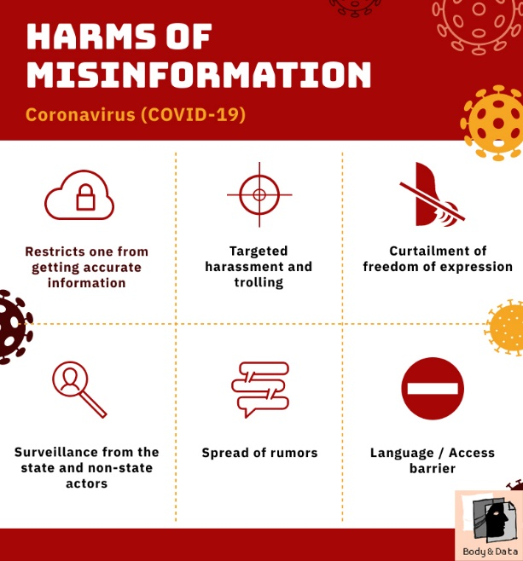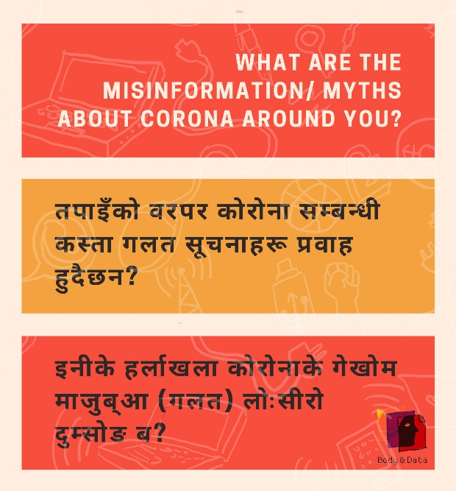

Campaign Against Online Violence
With the pandemic, there was a considerable rise on the cases on online violence in Nepal. To address the issues around it, we launched the campaign against online violence. Under this, we had a weekly webinar on “Understanding Online Gender Based Violence and Countering Them” for three weeks on June. The weekly seminars included topics such as “online gender based violence and its harms”, “online misogyny and its impacts” and “countering online gender based violence – tips and tools”.
In the campaign, we also mapped out cases reported by media around gender based violence, shared resources on how to prevent ourselves from getting attacked online, and what can we do when we’re being attacked online. We also shared resources on reporting mechanisms on social media platforms, along with laws that address online violence in Nepal and their criticisms.
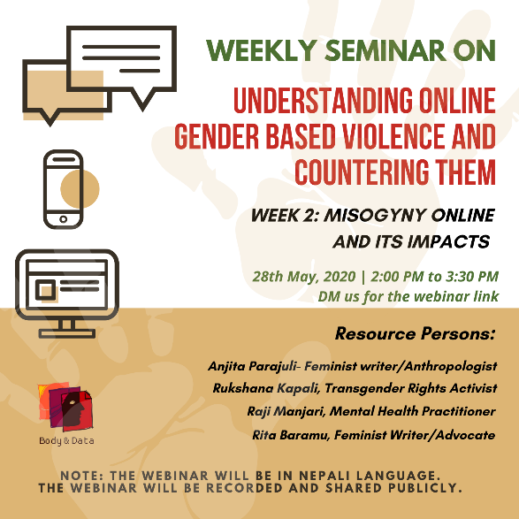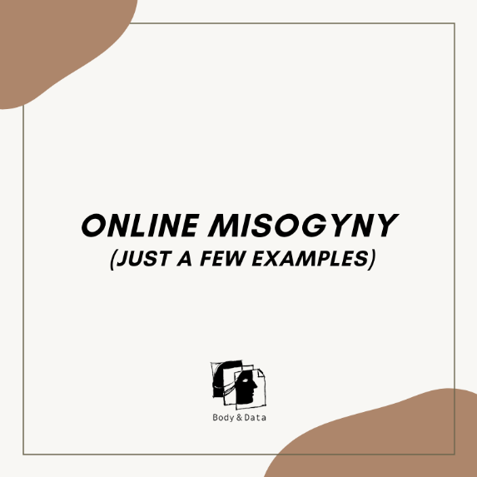

Privacy Campaign
There was a need to have a conversation around privacy during pandemic, and post pandemic times – what it meant for individuals to be surveilled and monitored. To address this, we launched a campaign on privacy, we released a series of comics on our social media where we addressed privacy concerns from our daily lives. 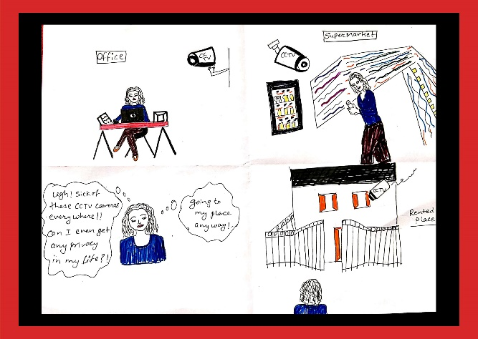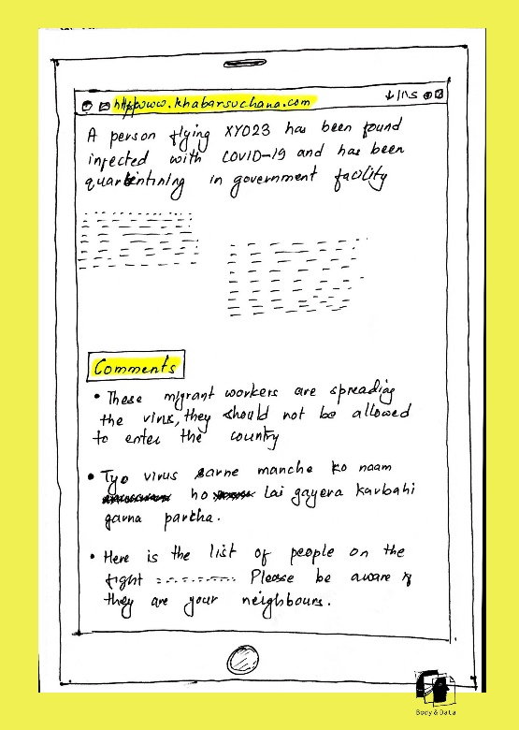

16 days of Activism – Mapping Laws Related to Online Violence in Nepal
Following the 16 Days of Activism against Gender Based Violence Against Women, we launched resources on mapping out laws relevant to online violence in Nepal, within the scope of digital rights in Nepal, with a focus on gender and sexuality. Three human rights lenses: Right to Privacy, Freedom of Expression and Free from Violence are used to analyze relevant laws.
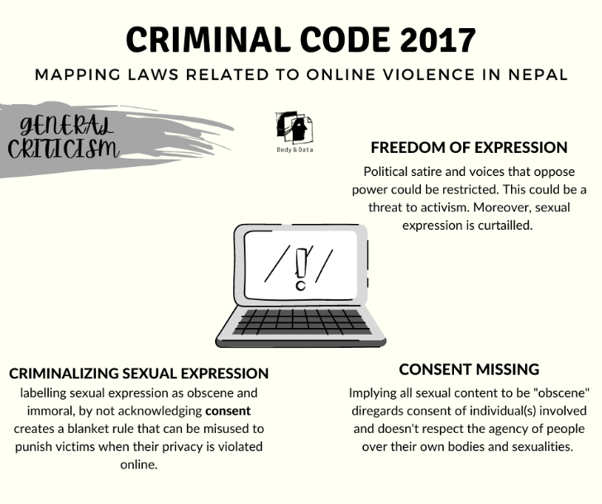

#SupportForNikisha
Following the huge numbers of harassment and online hatred targeted towards Nikisha, a content creator, we put out a statement of support and collected signatures. #SupportForNikisha was trending in Nepali twitter as a response to a video by a YouTuber where he is seen reacting to Nikisha's personal social media accounts including Tiktok videos taken and used out of context, neglecting Nikisha's narrative to the stories. This spewed a conversation online about the persistence of abundant hatred towards gender and sexual diverse people. 445 people signed the signature to condemn homophobia/transphobia on the internet.
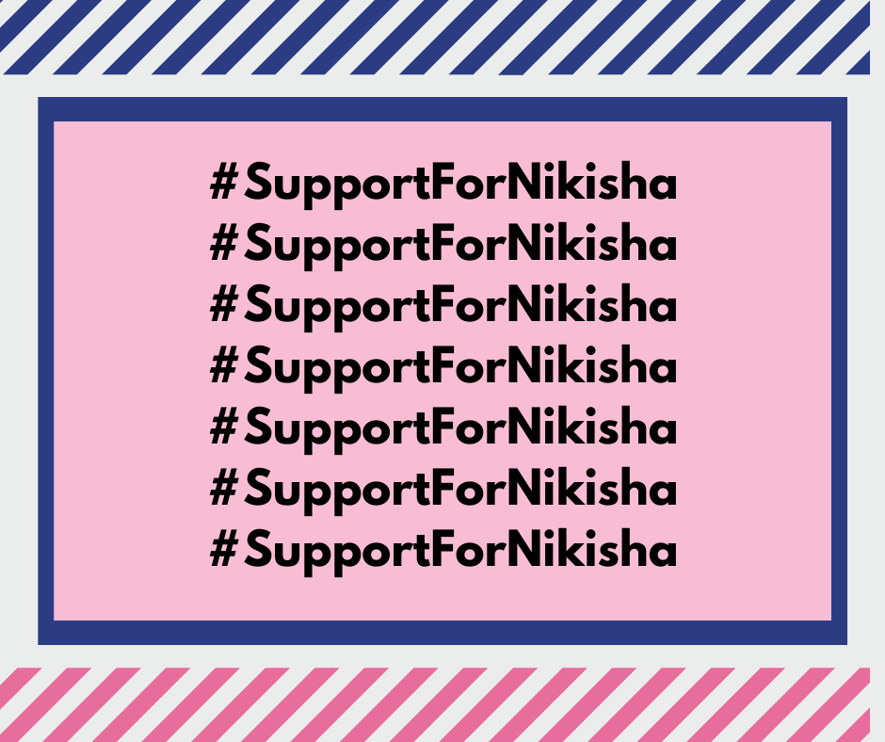

CONSTITUENCY BUILDING
We work with our communities - women, queer persons, tech enthusiasts, women rights activists, young people and civil societies through training programs. In 2020, we had the following workshops as a part of our capacity buildings.

- Digital Storytelling Workshop
In the year of 2020, we had opportunity to co-create space to organize two Digital Storytelling Workshops, one on February (in physical space) and other on August (virtually because of the Covid-19 pandemic). Having a space to choose a story of our lives that we have found influential, and be able to create a digital documentation of that story resonated with our idea of increasing the visibility of women and queer folks through their stories and put forward their multiple realities.
We were able to introduce storytelling, discuss the process of storytelling and its political essence in the feminist movement along with sharing of some technical skills on story production. By the end of workshop, participants were able to produce altogether 22 stories on their own. 24 queer folks, people with disability and young women activists were participated in the workshop.
Later, the stories were screened and shared through a screening event called “कथाका कुरा: Story Screening” where the communities we work with, along with ally organizations and activists were invited to witness these powerful stories. 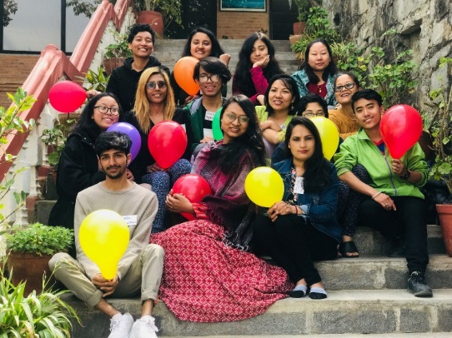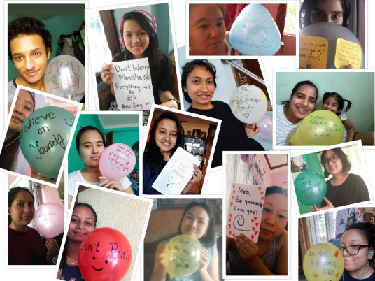

- Queering The Interweb: Digital Security Workshop
We co-created two spaces to learn, hack and work with our digital tools and platforms that are secured. During the month of November, we worked with 17 queer folks who participated in the workshops in the areas of digital security, intersectionality on gender, sexuality and internet, mapped out vulnerabilities and unique challenges as queer community and how we can mitigate such risks. The workshop became a space to learn about issues of digital rights and feminist internet, while working with hands on sessions of different security tools, and figuring out techniques that can make us safer while using technology and being ourselves online.
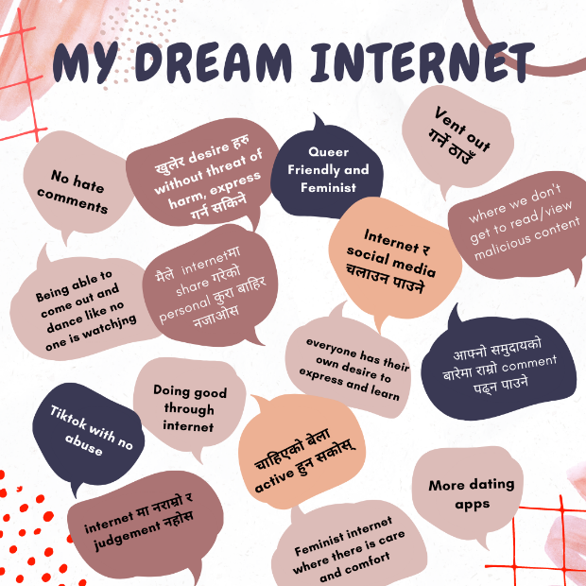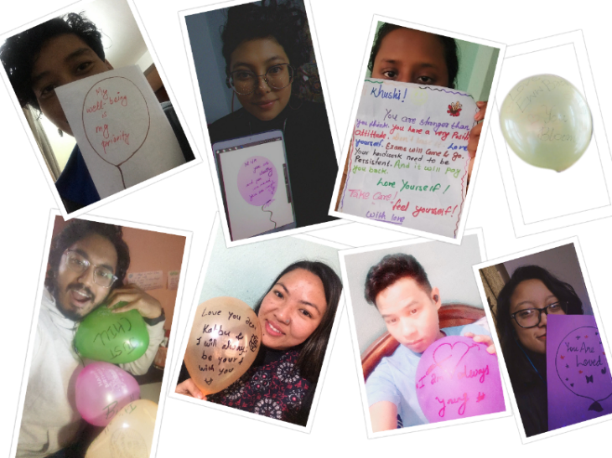

CROSS MOVEMENT COLLABORATIONS
The issue of internet freedom, let alone through a feminist lens is particularly new in the context of Nepal. Hence, we actively collaborated with different ally organizations working in the fields of gender, feminism, sexuality and digital rights, and tried to interlink the working areas of each other. We worked on building solidarity and collaborative movement building on our quest for a more feminist internet.

Cross Collaborations across National Movements:
Yantra Tantra
On the Safer Internet Day, we collaborated with Women Leaders in Technology to organize a one-day event where the conversation happened surrounding internet, data, sexuality, gender and the intersection of these elements; the risks and opportunities of engagement online, and what online security means for individuals. The event was a collaboration with young tech community.
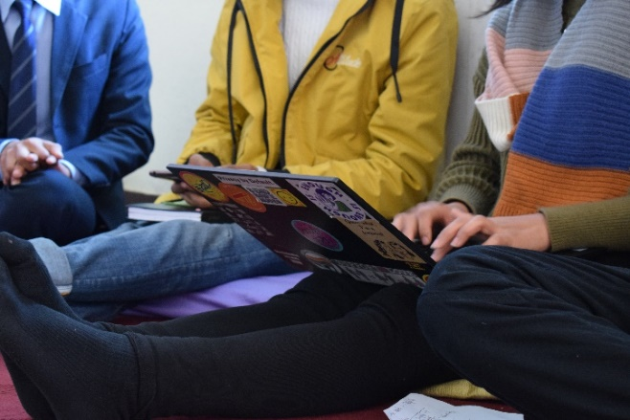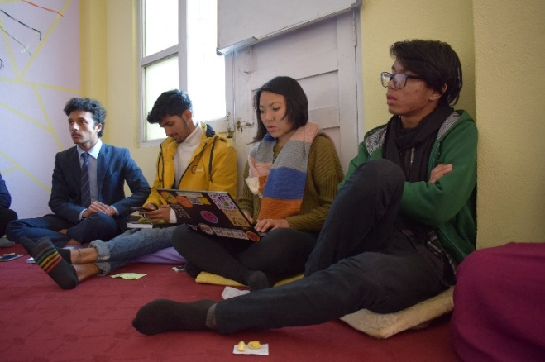

International Day against Queerphobia
On the International Day against Queerphobia, Body & Data in collaboration with Queer Rights Collective Nepal and Queer Youth Group organized a webinar to discuss the contemporary queer rights issues in the country. While unpacking of the term ‘third gender’ that the government of Nepal has recognize whether or not it is inclusive, the panel addressed various issues of intersex and trans communities in Nepal. The panel that included activists and individuals from the queer communities also spoke about queer relationship and marriage, queering mental health and shared experiences on organizing within the movement.
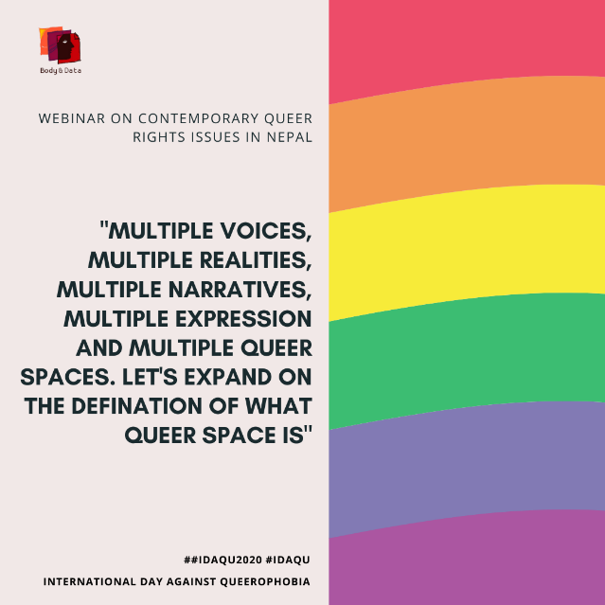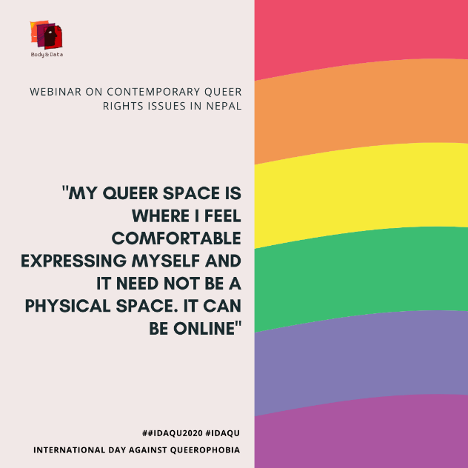
Sexuality Training for Visibly Impaired Women

We were with a part of “Sexuality Training for Visibly Impaired Women” organized by Prayatna Nepal. The two days’ sessions included a hands-on training on privacy and digital hygiene and discussion around the issues of intersectionality of gender, sexuality, disability and internet.
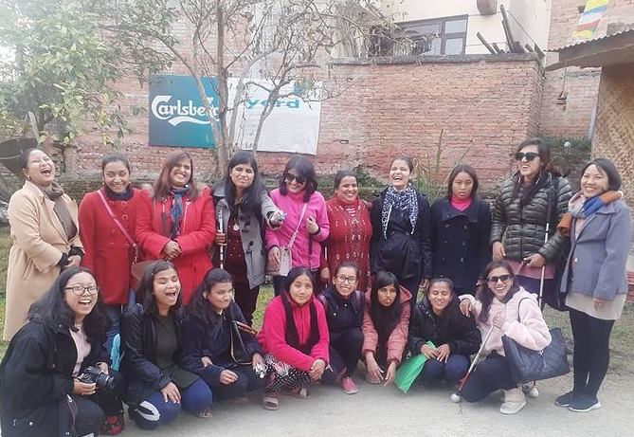

Session on Online Advocacy
In collaboration with Womens LEAD, Body & Data ran a session about the history, need and importance of online advocacy as well as some tools and tips while doing online campaigns to young women who were a part of Women LEAD course.
Collaboration with Prayatna Nepal for EROTICs Dissemination
We collaborated with Prayatna Nepal, an organization working to empower visually impaired girls and women. This collaboration was for dissemination of EROTICs qualitative research called “Beyond Access: Women and Queer Persons with Disability Expressing Self and Exploring Sexuality Online”
Consultation with Young People of Madhesh
We held a consultation with young people of Madhesh on access and usage of internet and technology with collaboration with Sanskriti – a youth led organization working in Birgunj. This is a part of – privacy consultation

Multi Stakeholder Discussion on Cyber Security Byelaw, 2077 by NTA
Body & Data collaborated with npCert and Centre for Cyber Security Research and Innovation for a webinar on Multi Stakeholder Discussion on Cyber Security Byelaw, 2077 by NTA. We talked about the intersectionality approach through the lens of gender and sexuality in the discussion around cyber security.
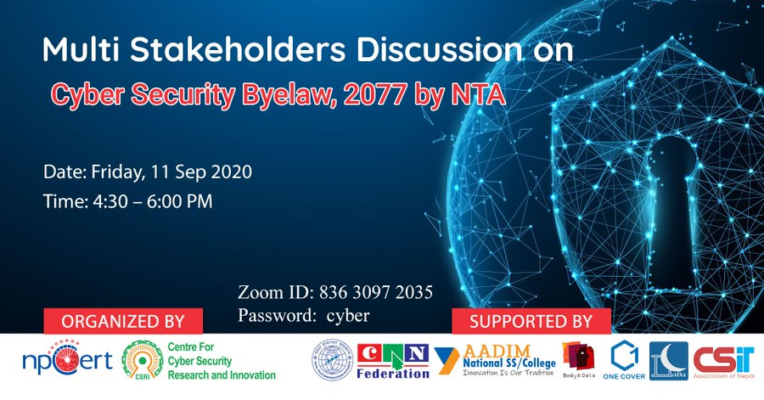

Webinar on “Freedom of Expression on Online World”
We collaborated on a webinar on “Freedom of Expression on Online World” with Martin Chautari and Freedom Forum. We contributed to the conversation through the ideas of freedom of expression, including sexual freedom, along with the privacy concerns on our day to day lives – online or offline.
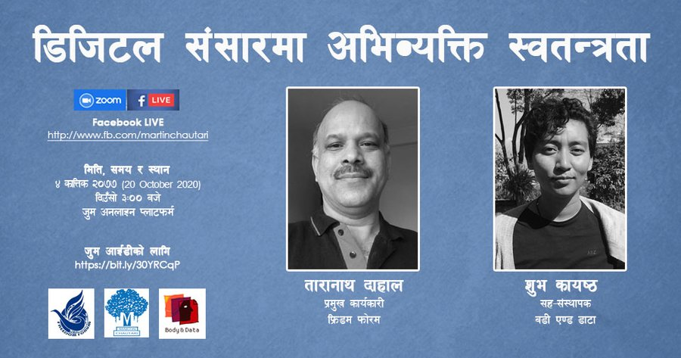

Cross Collaborations across International Movements:

#SayEnoughAsia Skillshop
Body & Data participated and held a session named “Memes, Muahs and Everything in The Middle” addressing different ideas about how we can campaign online, along with the pleasure aspects of online world. The #SayEnoughAsia Skillshop, brought together 30 regional campaigners & activists from across 12 countries across Asia working to end violence against women & girls. The three days was a celebration of the richness of feminist campaigning – it involved structured skill and knowledge sharing hosted by activists themselves sharing on feminist filmmaking, zines and comics, poetry, board games and deep dives into social norm change.
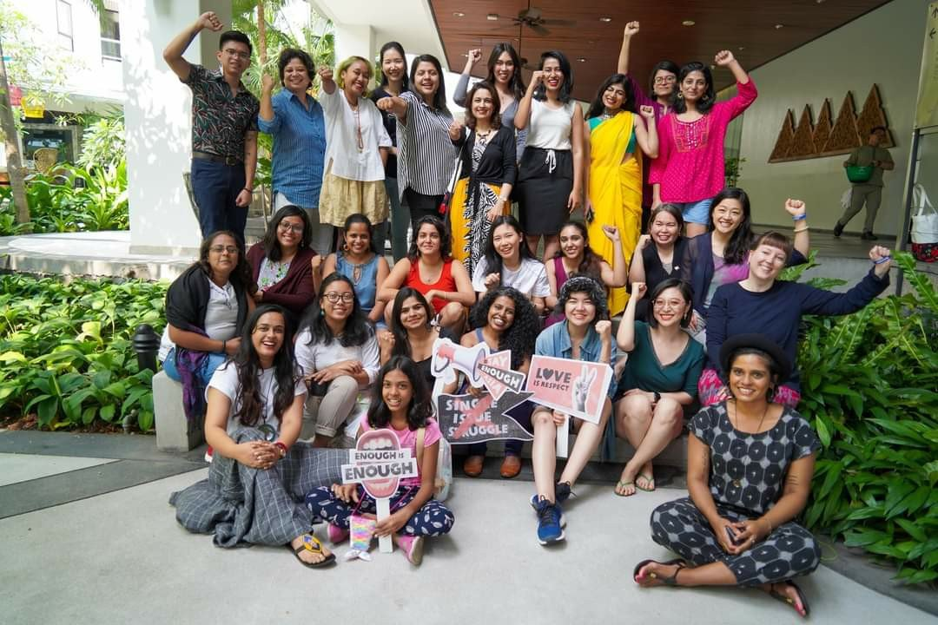

Digital Rights South Asia
We held space in the campaign called Digital Right South Asia by Association of Progressive Communications (APC) and CYRILLA to map out different laws relevant to digital rights in South Asia region. We shared different relevant laws in Nepal, along with the criticisms and analysis through the lens of gender and sexuality. The campaign also gave an opportunity to give resources made by Body & Data more visibility. 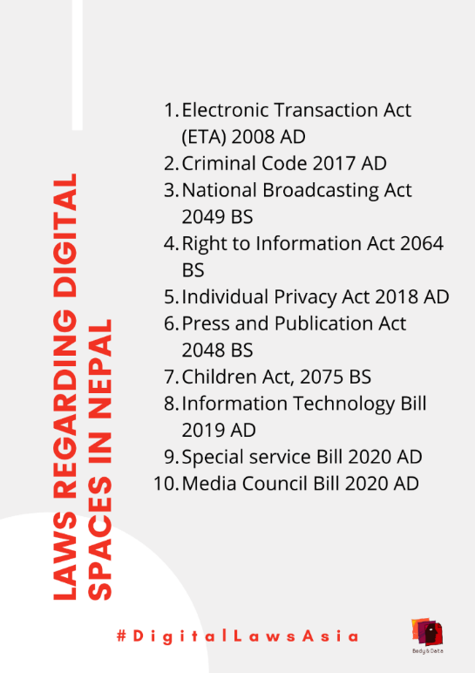

Tale of Tales
Body & Data facilitated a session on "Tale of the Tales" on APC convening on October held on virtual space. The 6 stories from the Digital Storytelling workshop 2020 were showcased and discussion was mode among the storytellers about their stories, their experiences throughout the story production and what are the feminist values and importance of bringing our stories. The convening was organized by APC on the occasion of their 30th anniversary.

Decolonizing Sexuality
In the Take Back the Tech Campaign, Body & Data conducted a session on “Decolonizng Sexuality” where the conversation happened around the colonial language that we use while talking about sexuality, the challenges and opportunities we face while we talk about sex, sexuality, gender and feminist principles of the internet within our communities. The session also included a conversation with fellow regional research partners of EROTICS and their experiences conducting the research and working with local communities.
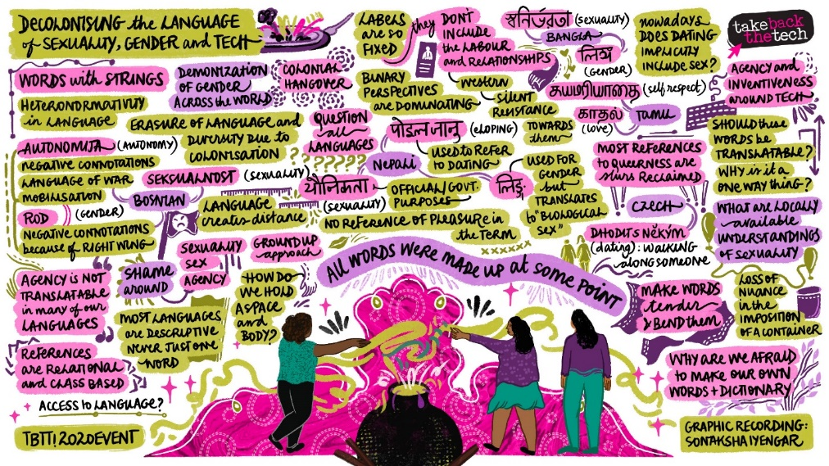

Internet Rules: Unboxing Digital Laws in South Asia
The workshop was organized by Association for Progressive Communications. The workshop had 10 sessions where we had opportunity to learn from experts who has been working to improve Digital laws in South Asia. We navigated through laws in South Asia that addresses Digital Rights directly or indirectly and learnt tools and resources to develop a right based approach while dealing with case scenarios relating to Internet. Furthermore, we also had the opportunity to highlight and facilitate a session for digital rights laws in Nepal.

Asian Pacific Regional Internet Governance Forum (APRIGF)
This year’s APRIGF was held virtually where we participated on a session proposed by Point of View (PoV) that focused on how critically looking at smart cities and facial recognition technology is seen as an indicator to development and how technology such as CCTV cameras and safety apps is seen as the solution for protection of women and children.

Twitter Chat with Hidden Pockets
On “Women, Queer Individuals and Privacy During Lockdown”, we virtually collaborated with Hidden Pockets for a twitter chat where we had conversations through five guided questions around alternative spaces for queer folks, privacy principles in technology, surveillance and data exploitation challenges, domestic/intimate partner violence during the lockdown and cyberbullying during the lockdowns. 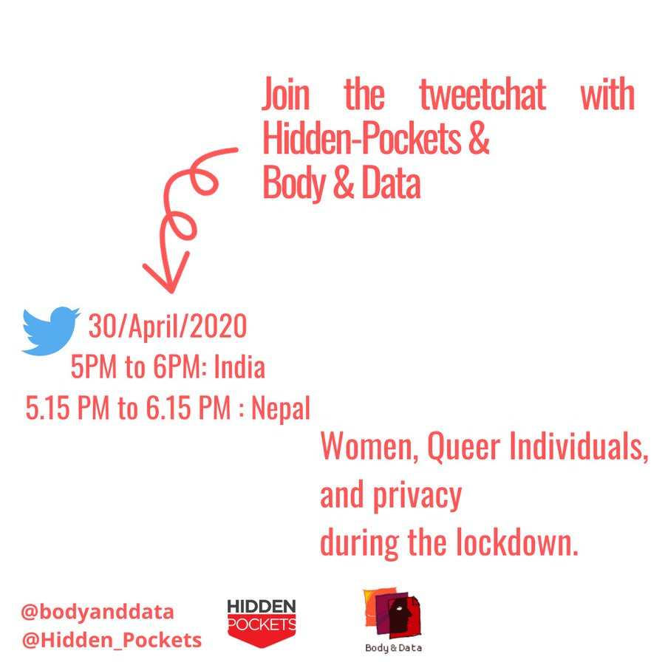

FORUMS AND AFFILIATIONS

For the year of 2020, we focused on occupying national, regional and global spaces, through independent or affiliated events where we were invited to facilitate sessions, speak on panels and participate in discourses on gender, sexuality, digital rights and feminist internet. We broadened our work through intersectionality while working in feminist and digital rights spaces and reach wider mass of youths, women and queer folks. An opportunity in the pandemic was being able to occupy more global and regional spaces through online webinars and plenary discussions.
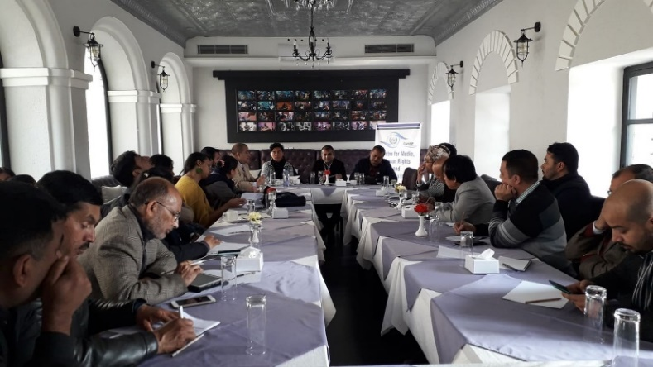
Public forum on “Digital Citizenship” organized by Galli Galli
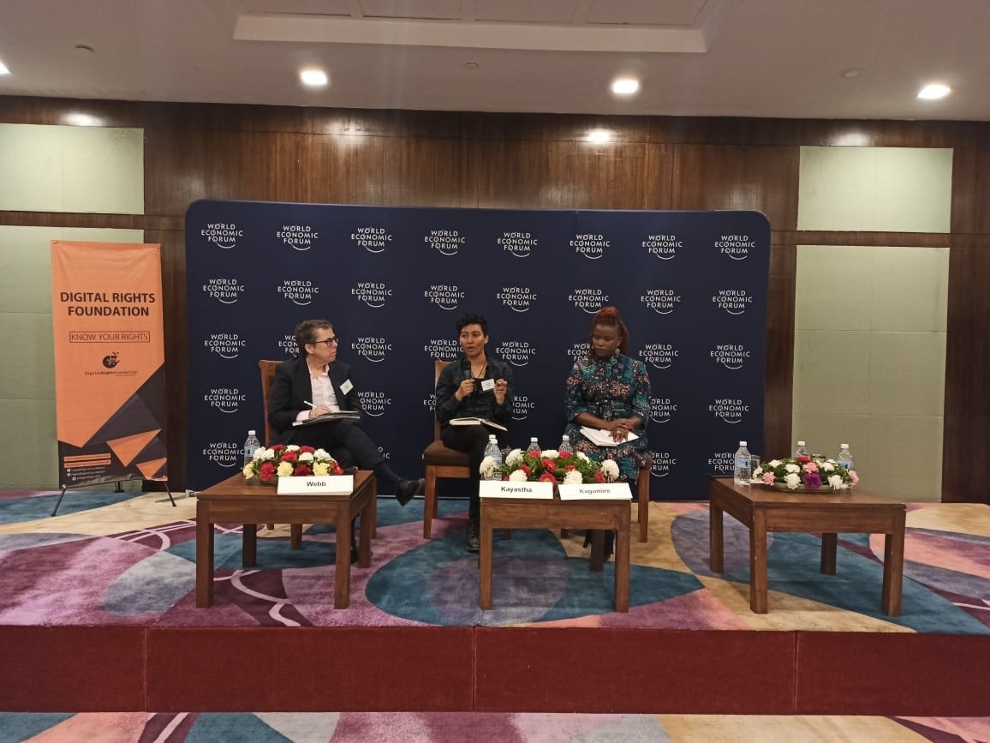
“Strategies for Organizational Change in the Fourth Industrial Revolution” at Mobilizing and Inspiring Action with Technology Workshop organized by World Economic Forum and Digital Rights Forum
"Safe Digital Space and Women in Technology" at Hamro Palo Webinar for Adolescent Girls
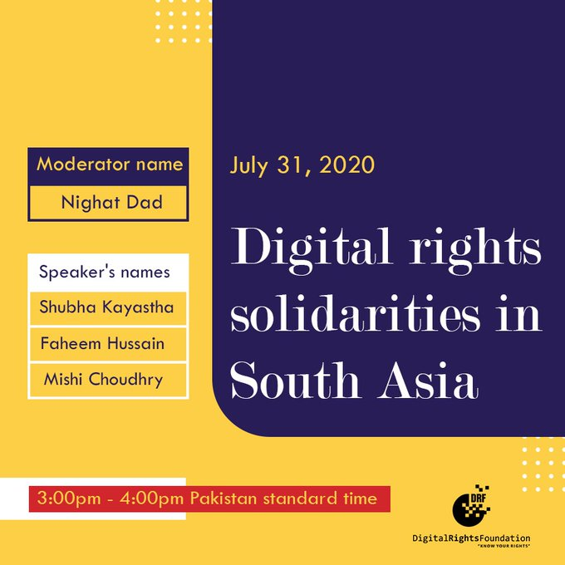
'Digital rights solidarities in South Asia' during RightsCon 2020 hosted by Digital Rights Foundation (DRF)

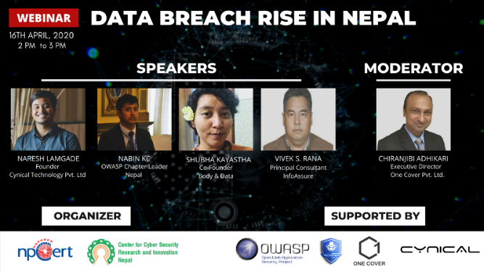
Webinar on "Data Breach Rise in Nepal" by NpCert and Centre for Cyber Sexuirty Research and Innovation Nepal
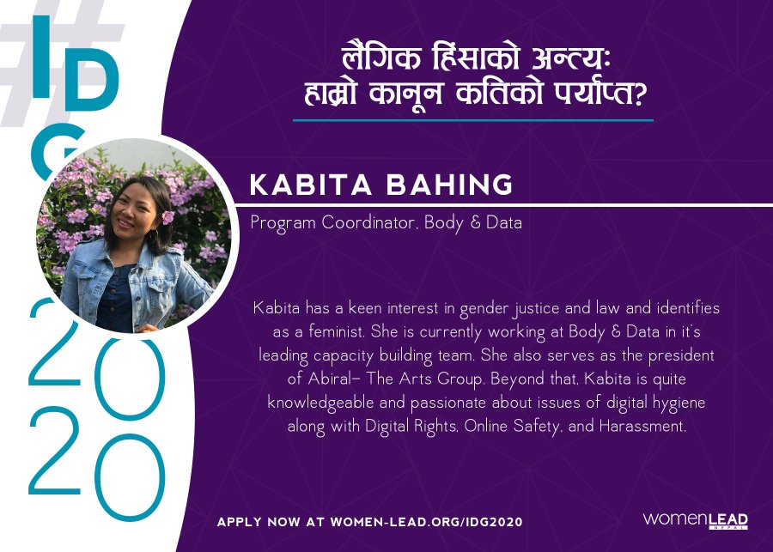
“Gender Based Violence and Efficiency of Laws” in the event of International Day of Girl Child, by WomenLEAD
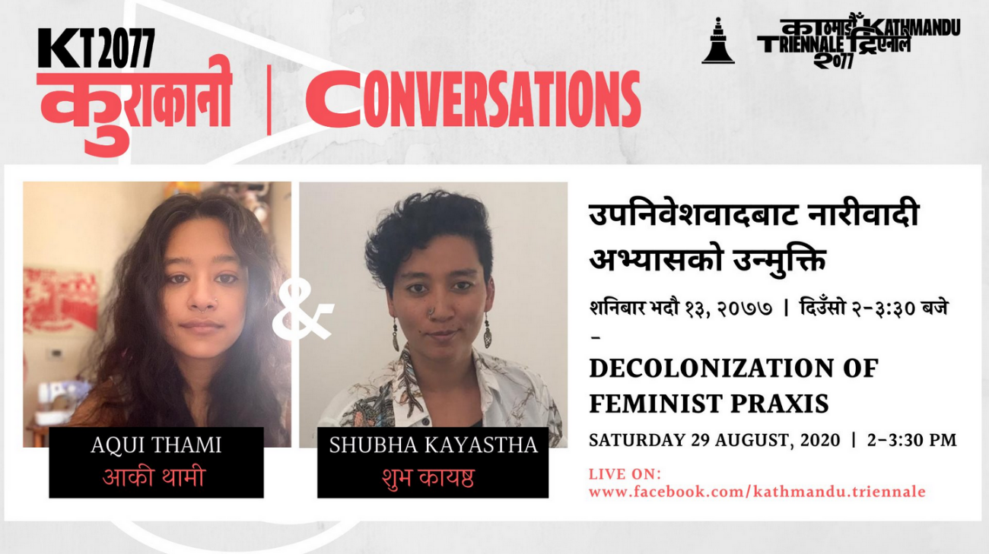
Decolonization of Feminist Praxis by Kathmandu Trienniale

- “Digital Technology and Human Rights” organized by COCAP

- “Impact of COVID 19 on the rights of marginalized people in Nepal” by COCAP

- "The Digital Age, Hate Speech and New Forms of Communication" in the event Feminist brainstorming and intergenerational dialogue organized by Women's Media Collective (WMC) and International Centre for Ethnic Studies (ICES).

- Vella Panthi #2- A Conversation on Consent in Digital Space organized by Rising Flames

- ‘Privacy and Data Protection in the Fight against COVID-19’ organized by Innovation for Change South Asia

- “Gender Based Violence and Efficiency of Laws” in the event of International Day of Girl Child, by WomenLEAD

- "The Future of Assembly: Human Rights in a Brave New World", participation in consultation organized by Forum Asia and CIVICUS for report to the Human Rights Council by a UN Special Rapporteur

PUBLICATIONS
Body & Data. (2020). Online Gender Based Violence: Mapping Laws Related to Online Gender Based Violence in Nepal. Retrieved from Body & Data: https://bodyanddata.org/ogbv-laws-mapping-chart/
Body & Data. (2020). Unshackling Expression: A Study on Criminalisation of Freedom of Expression Online in Nepal. Body & Data, Association for Progressive Communications (APC), Cyrilla Initiative. Retrieved from Association for Progressive Communications: https://www.apc.org/sites/default/files/Report_Nepal_20.11.25.pdf
Kayastha, S., Pokharel, M., (2020). Beyond access: Women and queer persons with disabilities expressing self and exploring sexuality online. Body & Data. Retrived from Body & Data: https://files.bodyanddata.org/nextcloud/index.php/s/etpDJAS7w7Poi3B#pdfviewer
Kayastha, S., Pokharel, M., (2020).Identities Experiencing the Internet: Nepal Survey Report. Body & Data. Retrived from Body & Data: https://files.bodyanddata.org/nextcloud/index.php/s/jsnQBzfGyDso4Kj#pdfviewer

MEDIA
Kapali, R. (2020, June). #34 Guff Gaff with Rukshana Kapali. (B. Bajai, Interviewer)
Kayastha, S. (2020, June). #36 Guff Gaff with Shubha Kayastha: Smile, Please - Sarkar Is Watching! . (B. Bajai, Interviewer)
Kayastha, S. (2020, May 7). Cyberlaw and Data Privacy in the Time of Pandemic. (I. Frame, Interviewer)
Kayastha, S. (2020, July 17). Episode 5: Understanding our Digital Platform. (Avant-Garde-Graspe, Interviewer)

ARTICLES
Body & Data. (2020, March 26). Privacy in the Pandemic. Retrieved from Body & Data: https://bodyanddata.org/privacy-in-the-pandemic/
Body & Data. (2020, October 13). Raper Association and Systemic Misogyny. Retrieved from Body & Data: https://bodyanddata.org/raper-association-and-systemic-misogyny/
Body & Data. (2020, July 23). अभिव्यक्ति हाम्रो अधिकार. Retrieved from Body & Data: https://bodyanddata.org/अभिव्यक्ति-हाम्रो-अधिकार
Kayastha, S. (2020, March 29). Corona epidemic in Nepal and misinformation. Retrieved from Setopati: https://en.setopati.com/blog/152549
Kayastha, S. (2020, June 23). Digital Debacles. Retrieved from The Record: https://www.recordnepal.com/perspective/opinions/digital-debacles/
Kayastha, S. (2020). Feminist Navigating Digital Space and Countering Technology 'Enabling' Violence. ARROW for Change: The Right to Freedom of Speech and Expression!, 6.
कायस्थ, श. (२०७६ , चैत २३). कोरोना महामारी र गलत सूचनाको हानी. Retrieved from Setopati: https://www.setopati.com/opinion/203179
कायस्थ, श. (2076, Magh 11). इन्टरनेटसम्बन्धी मिथ्या ज्ञान. Retrieved from Kantipur Daily: https://ekantipur.com/bibidha/2020/01/25/157992018387633096.html?author=1
बरामु, र. (२०७६ , फाल्गुण १७). प्रविधिकोे पञ्जामा मानवअधिकार. Retrieved from Naya Patrika Daily: https://jhannaya.nayapatrikadaily.com/news-details/1021/2020-06-20
बरामु, र. (२०७७, माघ ६). यौनिक अभिव्यक्तिमाथि नियन्त्रण किन ? Retrieved from Naya Patrika Daily: https://jhannaya.nayapatrikadaily.com/news-details/861/2020-02-29
लामिछाने, स. (2020, December 9). अपाङ्गता भएका महिला तथा क्वेर व्यक्तिहरूको प्रविधिमा पहुँच. Retrieved from Body & Data: https://bodyanddata.org/blog-women-with-disability-and-access/

OUR TEAM

Board Members

Supriya Manadhar
Supriya is an art director and freelance illustrator. She has also dabbed in journalism, working as desk editor of The Record in 2017 - 2018. Supriya comes from formal background in the visual arts and art education. She is a feminist and a Newa activist.

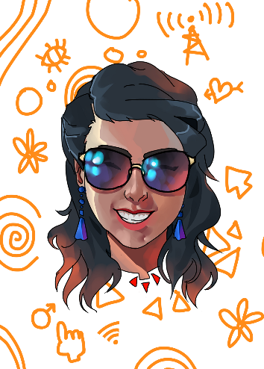
Sarita Lamichhane

Sarita is a visually impaired change maker. She is the founder of Prayatna Nepal which is an organization working to empower visually impaired women to take their lives in their own hands. Apart from this, she is also a professional motivational speaker.

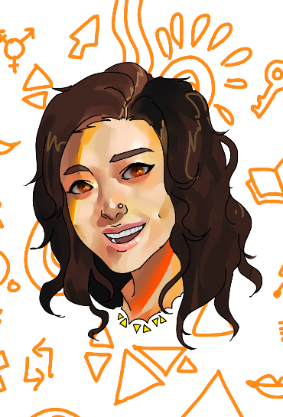
Dovan Rai

Dovan did PhD in Computer Science researching on education technology - at the intersection of education psychology, game design, datamining and Artificial Intelligence. She has worked with OLE Nepal for designing educational software for public schools of Nepal. She identifies as a feminist and socialist and she is looking for ways to make feminist socialist impact through technology, particularly AI.

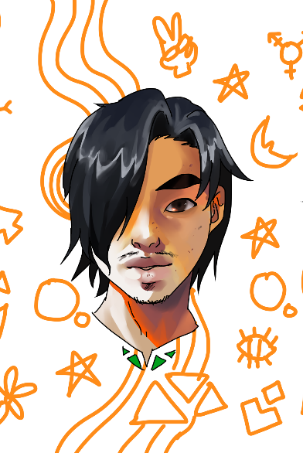
Bharat Shrestha

Bharat is a professional developmental worker on the field of public health, education and social science. He is also a queer activist.

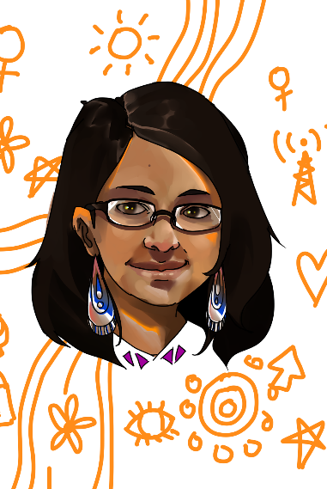
Pallavi Payal

Pallavi Payal is a political researcher and a feminist Mithila artist exploring ideas to re-invent Mithila art in current times to try to explain the impact of the citizenship amendment bill on Madhesi women, the culture of silencing women and other patriarchal and misogynistic mind-set that affects the lives of women, through Mithila Art.

Staff Members
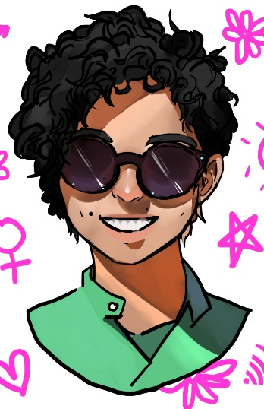
Shubha Kayastha

Shubha is the co-founder and executive director at Body & Data. She comes from a background of women's sexual and reproductive health and rights (SRHR). You can find her talking about digital rights, feminist internet, sexual expression and pleasure!

Rita Baramu

Rita is a feminist writer who comes from the background of gender, law and land rights. You will always find her speaking her mind about women's, ethnic and minorities' issues, and leading with a feminist perspective at Body & Data. Being paradox of loud laugh and soft voice, Rita is a force to reckon with.
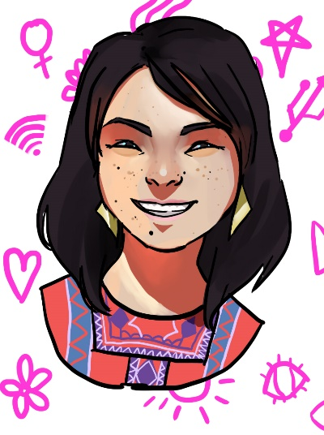
Kabita Rai

Kabita is a feminist and LLB graduate with masters in Gender Studies. She has a history of working with child and youth at risk, and is involved in the indigenous movement. Kabita is also associated with Abiral - The Arts Group and Accountability Lab as Nepal Accountability Incubator

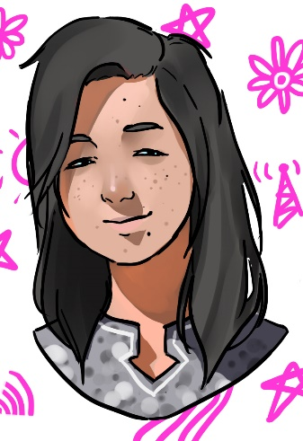
Youba Rai

Youba has been handling the administration and finances of Body & Data. Originally from Sankhuwasabha, Youba has been working in the field for past 7 years. She is definitely residential superwoman.

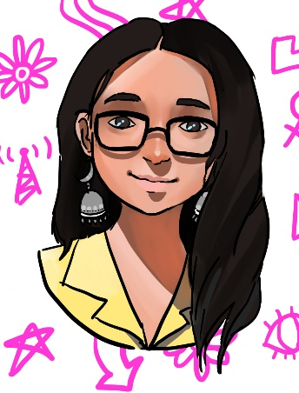

Shripa Pradhan

Shripa is a feminist and has been a debater in the past. She is a psychology major and loves Narratives Practices. You can always catch her enthusiastically speaking about BTS, her favorite band.

PARTNERS AND SUPPORTERS

We would like to thank our partners and supporters, who believed in our goals and helped shape the organization for 2020. We also appreciate Vision for Change for their support.
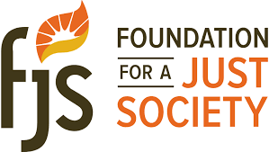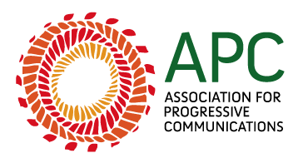

We again, would like to thank all of our team members, ally organizations, partners, and enthusiastic individuals for making 2020 a year for collective movement, care, support and resistance as we strive forward for integration of feminism, technology and internet rights. We hope to increase more autonomous participation, agency and visibility of women and queer people online through digitally secure strategies in 2021.
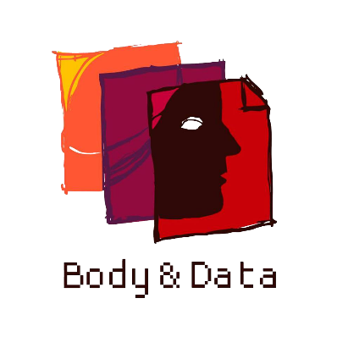

Website:
bodyanddata.org

Twitter/Instagram/Facebook:
@bodyanddata

